Pizza Hut, Charmin Latest to Create NFTs
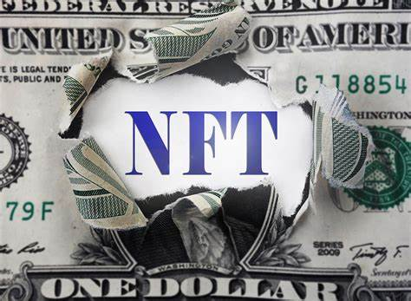
Pizza Hut and Charmin are the latest brands to venture into the NFT -- or non-fungible token -- art world. Pizza Hut Canada touted four new flavors with its "1 Byte Favorites" NFTs, one of which was bought for the brand's price of the equivalent of 18 cents and has gone back on Rarible's market for $8,824.07, while Charmin's toilet paper NFTs are seeing bids as high as $264.72.
MediaPost Communications (free registration) 3.17.21
https://www.mediapost.com/publications/article/361515/charmin-takes-crypto-leap-into-the-nft-art-world.html
Image credit:
https://futuristspeaker.com/wp-content/uploads/2021/03/futurist-thomas-frey-non-fungible-tokens-nft-new-digital-art-market.jpg

