Pokémon Go Fever Hits Russia, Making Kremlin Nervous
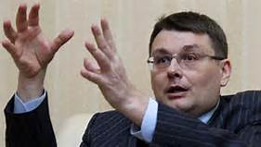
Russia's government is wary of the phenomenon. Dmitry Peskov, a spokesman for Russian President Vladimir Putin, suggested in July that playing Pokémon at the Moscow Kremlin and other cultural sites is disrespectful. Lawmaker Evgeny Fedorov warned in an online post that Pokémon Go could help assemble political protests.
Advertising Age 8.1.16
http://adage.com/article/digital/pok-mon-fever-hits-russia-making-kremlin-nervous/305273/?utm_source=mediaworks&utm_medium=newsletter&utm_campaign=adage&ttl=1470687202

