Police Detain Reporters Again
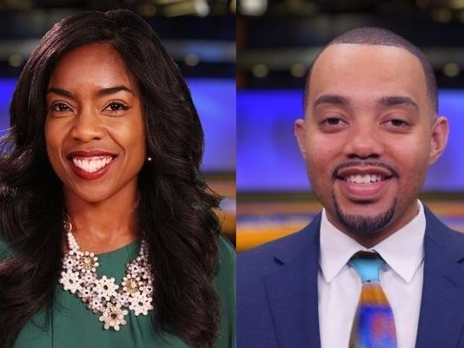
In Rochester, two reporters were detained and handcuffed by officers over the weekend while they were reporting live via Facebook from a public sidewalk. The journalists, Carlet Cleare and Justin Carter, both from WHAM Television, were led away by police. The pair were the only African Americans who were part of a larger group of reporters in the area.
RTDNA 7.11.16
http://rtdna.org/article/police_detain_reporters_again

