Police Have Been Spying on Black Reporters and Activists for Years
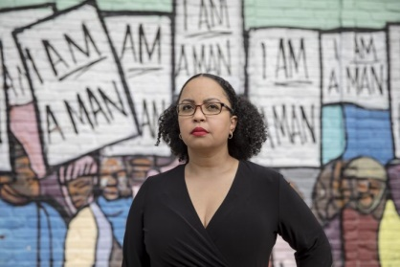
On Aug. 20, 2018, the first day of a federal police surveillance trial, I discovered that the Memphis Police Department was spying on me. The ACLU of Tennessee had sued the MPD, alleging that the department was in violation of a 1978 consent decree barring surveillance of residents for political purposes.
Nieman Lab 6.10.20
https://www.niemanlab.org/2020/06/police-have-been-spying-on-black-reporters-and-activists-for-years-i-know-because-im-one-of-them/?utm_source=Listrak&utm_medium=Email&utm_term=Police+Have+Been+Spying+On+Black+Reporters&utm_campaign=Nexstar+Remains+Firmly+Atop+Station+Groups
Image credit:
https://www.niemanlab.org/images/wendi-c.-thomas-copyright-andrea-morales-700x467.jpeg

