Political Ad Spend To Reach $6 Billion For 2020 Election
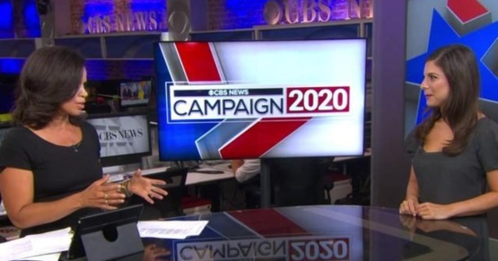
Growth in political ad spending is expected to slow dramatically during the 2019-2020 election cycle, according to Kantar Media, which predicts political campaigns for US federal office will spend $6 billion on paid media placements this year. But a greater share than ever will be directed toward digital channels.
eMarketer 7.19.19
https://www.emarketer.com/content/political-ad-spend-to-reach-6-billion-for-2020-election?ecid=NL1001
Image credit:
https://cbsnews2.cbsistatic.com/hub/i/r/2019/07/16/a44f734a-7637-4169-b2dc-152f98e62faf/thumbnail/1200x630/f0ca3af5dd6b1128fdebd4c8686e939f/cbsn-fusion-political-video-ad-spending-expected-to-grow-in-2020-thumbnail-1892520-640x360.jpg

