PR Industry Strives Toward Diversity
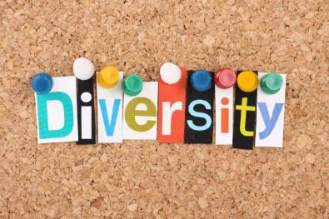
The public relations industry is making strides toward diversity as Diversity Month is celebrated, and the efforts are beginning to transform the industry, writes Ana Toro, APR. PRSA works annually to recognize strides made with its PRSA Chapter Diversity Awards at its diversity conference, and it has created the PRSA National Diversity & Inclusion Committee to further industry efforts.
PRSAY 8/1/16
http://prsay.prsa.org/2016/08/01/lack-of-prdiversity-makes-diversity-month-ever-more-relevant/

