PR Pros Share Advice For Younger Females
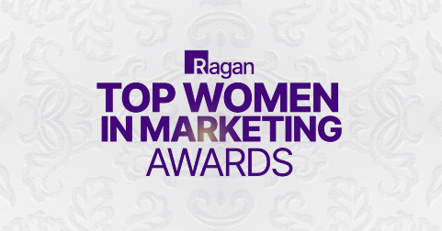
Female PR practitioners shared advice they'd give their younger selves during last year's PR Daily's Top Women in Marketing Awards event. Stanley Brand's Sue Dietrich warned against burning bridges. Gaming Laboratories International's April Augustine would tell her younger self to "own her expertise," and Myers Squibb's Aliah Davis McHenry said she "would tell her to be bold" and "not let anyone steal her joy."
PR Daily 3/12/24
https://www.prdaily.com/ragan-and-pr-dailys-top-women-in-marketing-class-of-23-on-the-advice-theyd-give-their-younger-selves/
Image copyright:
https://s39939.pcdn.co/wp-content/uploads/2024/01/social-share_toDevTeam@2x-1-1024x536.png

