PRI, PRX Merge to Form New Organization
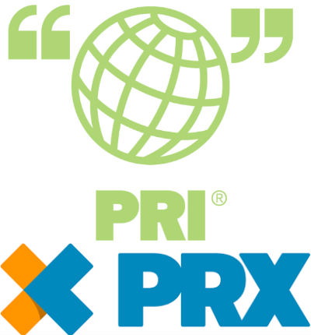
Public Radio International and PRX will merge under an unusual arrangement that allows both to maintain separate identities and program portfolios. The deal is backed by WGBH, which acquired PRI in 2012 and maintained its separate leadership structure and governance.
Current 8.15.18
https://current.org/2018/08/pri-prx-merge-to-form-new-organization/
Image credit:
https://www.allaccess.com/assets/img/editorial/raw/pr/priprx2018.jpg

