Nielsen Will Measure Viewership For NFL On Amazon
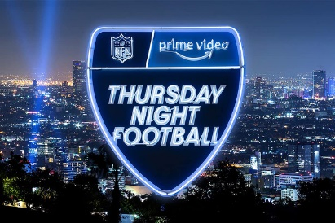
Nielsen will track the ratings for Amazon Prime Video's exclusive "Thursday Night Football" telecast starting next month under a three-year agreement, the company's first time monitoring a live-streamed show. Out-of-home viewing and activity on the Twitch gaming service will be among the metrics Nielsen reports.
Variety 8.16.22
https://variety.com/2022/tv/news/nielsen-amazon-thursday-night-football-tv-ratings-measurementt-1235341981/
Image credit:
https://s3-prod.adage.com/s3fs-public/styles/width_660/public/20220812_skylinelogo_3x2.jpg

