Print Edition of a Missouri University's Magazine Has Been Canceled.
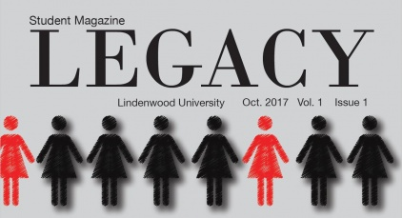
While administrators at a private university near St. Louis say they killed a student magazine to ensure a digital focus, editors say it is retaliation for recent controversial articles. Part of the review discussed how to "foster an attitude of 'digital first.'" Madeline Raineri, the current news editor of The Legacy, said students were told at the meeting that "print isn't important and that the experience behind printing could be replicated exactly just with publishing something online." The students were also told that the cost of printing a magazine was a concern.
The Student Press Law Center 7.10.18
http://www.splc.org/article/2018/07/lindenwood-legacy?utm_source=Student+Press+Law+Center+newsletter&utm_campaign=97eedcdcca-EMAIL_CAMPAIGN_4_26_2018_COPY_01&utm_medium=email&utm_term=0_8fab1c40ea-97eedcdcca-138474105
Image credit:
http://lindenlink.com/wp-content/uploads/2017/10/Legacy-Magazine-cover-tease-422x229.jpg

