Round Raises $200M For Gaming Startup ProbablyMonsters
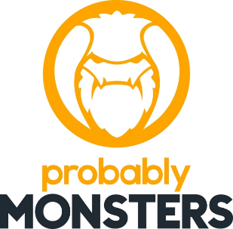
Video game startup ProbablyMonsters raised $200 million in its Series A funding round which it will use to fund expansion and increase community engagement. "Our goal is to make ProbablyMonsters a home where developers with vision can build a meaningful career, thrive in a positive culture, and deliver amazing experiences to generations of gamers across the world," said CEO Harold Ryan.
GeekWire 9/1/21
https://www.geekwire.com/2021/seattle-area-video-game-company-probablymonsters-raises-200m-grow-family-studios/

