Pro-Hillary PAC Spending on TV and Radio Ads Surges Past $100M
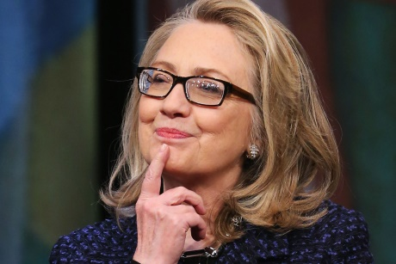
Last week, we served up a single interactive map: a state-by-state view of TV and radio ad spending so far. This week offers a ranked view of TV and radio ad spending by candidates (including the dropouts) and the PACs and advocacy groups supporting them, as well as an interactive spending-by-date view for the three remaining major candidates plus the two most recent dropouts, Ted Cruz and John Kasich, for comparison purposes.
Advertising Age 5.27.16
http://adage.com/article/campaign-trail/TV-radio-spending-by-pro-Hillary-Clinton-PACs-$100-million/304167/?utm_source=daily_email&utm_medium=newsletter&utm_campaign=adage&ttl=1464996909

