Proposed Bill Turns The Volume Down On Streaming Ads
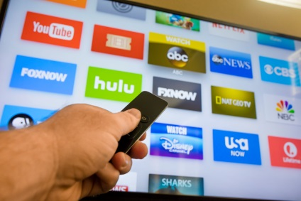
The Commercial Advertisement Loudness Mitigation Act of 2010, which requires that ads be the same volume as or quieter than programming, would apply to streaming services if a bill in Congress passes. A pair of Democrats proposed the legislation in both houses.
Nextgov 3/31/23
https://www.nextgov.com/policy/2023/03/proposed-bill-would-ban-excessively-loud-streaming-commercials/384688/
Image credit:
https://www.bing.com/images/search?view=detailV2&ccid=6ooTiV%2bx&id=52280B9E5C099AFA85BD620B4D8CB549066282CB&thid=OIP.6ooTiV-xZbiNNd4Ew7adaAHaE7&mediaurl=https%3a%2f%2fcdlnws.a.ssl.fastly.net%2fimage%2fupload%2ff_auto%2cq_auto%2fv1522338717%2fStreaming_TV_Apps_kyotau.jpg&cdnurl=https%3a%2f%2fth.bing.com%2fth%2fid%2fR.ea8a13895fb165b88d35de04c3b69d68%3frik%3dy4JiBkm1jE0LYg%26pid%3dImgRaw%26r%3d0&exph=2533&expw=3800&q=+TV+Streaming&simid=607989244427724066&FORM=IRPRST&ck=FC2F48831DA9F7A3D252CFBEDDD4508E&selectedIndex=4

