Public College Refuses to tell Faculty they can Talk to Student Journalists Without Permission
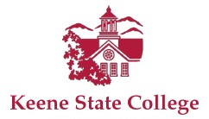
By its actions if not its explicit words over the past year and a half, New Hampshire’s Keene State College has been leading employees to believe they can’t speak with student journalists or even the local media without getting in trouble.
The College Fix 6.6.17
https://www.thecollegefix.com/post/33059/

