Puerto Rico Broadcasters Stay On Air Despite Outages

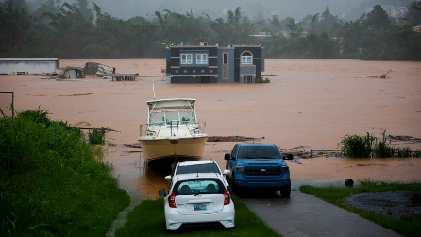
Television and radio broadcasters across Puerto Rico remain on air, keeping communities informed in the wake of Hurricane Fiona, which caused widespread flooding and knocked out power and internet service for large parts of the island. The Spanish Broadcasting System is coordinating with the National Guard and Coast Guard to support relief efforts, says Executive Vice President Jesus Salas.

Radio and Television Business Report 9/20/22

https://www.rbr.com/puerto-rico-media-overcomes-severe-storm-damage-from-fiona/

Image credit:
https://s.abcnews.com/images/US/hurricane-fiona-puerto-rico-ap-jt-220919_1663597965481_hpMain_16x9_992.jpg

