PVOD Film Debuts May Continue As COVID Variants Spread
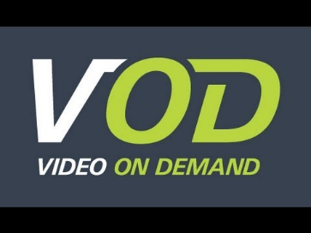
Despite pushback from movie theater companies and Hollywood stars, premium video-on-demand may enjoy a second life in homes as the COVID-19 pandemic lingers with the spread of the Delta variant, David Bloom writes. He notes that many people remain wary of returning to theaters and PVOD offerings are boosting streaming services while returning some revenues to studios.
Next TV 8.4.21
https://www.nexttv.com/news/pvod-isnt-dead-yet
Image credit:
https://www.youtube.com/watch?v=2Jacy8CLN2E

