Report: Radio Ad Revenue Flat in 2016
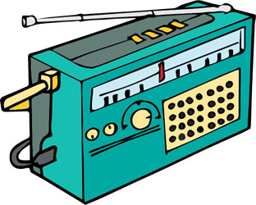
Overall, Standard Media Index says ad spending was up 6.8% in 2016, the big gainer was digital, jumping 13.3% for the year. However, that’s a far cry from what digital gained in 2015, which was 50%. Out-of-home advertising increased 6.9%, TV spending was up 4.4%, and radio was virtually unchanged — down 0.5%.
RadioInk 1.25.17
http://radioink.com/2017/01/25/report-radio-revenue-flat-2016/?utm_source=ActiveCampaign&utm_medium=email&utm_content=How+Much+Ad+Revenue+Did+Radio+Receive+in+2016%3F&utm_campaign=Wednesday+Pai

