Radio Growth Will Accelerate During 2H 2023
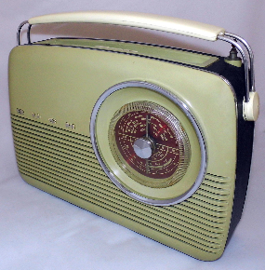
The radio industry will experience some challenges in the first quarter of 2023, but have continued quarterly growth and strong momentum by the second half of the year, industry experts predict. Radio gives advertisers good value "with the lowest CPM's of all the major media platforms," says iHeartMedia CEO Greg Ashlock.
Inside Radio 1.3.23
https://www.insideradio.com/free/2023-s-biggest-momentum-will-come-in-second-half-industry-leaders-predict/article_d6f9bcf0-8b2a-11ed-86d8-af178cdf4a2d.html
Image credit:
https://live.staticflickr.com/1576/26258100550_5c71bbdbdf_b.jpg

