Radio's Reach Consistent Over Last 15 Years
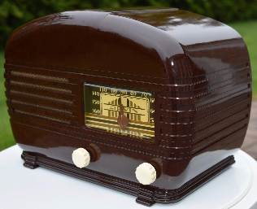
Broadcast radio has 214 million listeners, a decrease of just 8% from 2008, and eMarketer reports that it's still a valuable advertising format. The study also predicts a 30% rise in ad spending for podcasts this year.
Inside Radio 12.12.22
https://www.insideradio.com/free/radio-still-safe-bet-for-advertisers-says-emarketer-report/article_65628c7a-79f5-11ed-80f9-7fb4983ad51c.html
Image credit:
https://1.bp.blogspot.com/-w1BWipU37-4/XO_20rIFl9I/AAAAAAAAGK0/668l7DiO9w09GlDivFbZqC9WRC9_Hw5ewCLcBGAs/s1600/DSC_0004.jpg

