Kentucky Radio Station Helps Local Community Rebuild
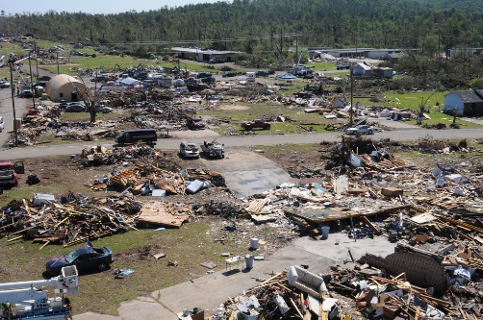
Radio host Carla "Tess" Cowan and her colleagues at WPKY have dedicated themselves to helping their community maintain a normal routine during the pandemic, and now they're working to support recovery efforts in the wake of deadly tornadoes. The station is providing listeners with information on local needs and where donations can be dropped off and urging people to take care of themselves throughout what will likely be a lengthy recovery process.
Poynter 12/15/21
https://www.poynter.org/reporting-editing/2021/how-a-local-radio-station-is-helping-a-tornado-battered-kentucky-community-put-itself-back-together/
Image credit:
https://naction.org/wp-content/uploads/2021/12/Largest-Tornado-in-Kentucky.jpg

