Radio Stations Keep Communities Connected During Storm
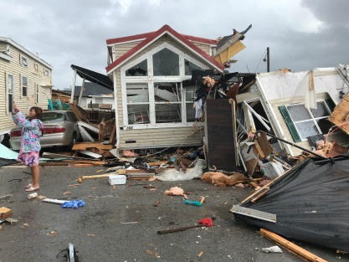
Radio stations across the Carolinas stayed on the air to reassure local residents, provide emergency updates and answer listener requests for assistance as Hurricane Dorian lashed the coastal states. Cox Media Group, iHeartMedia and Entercom have all announced efforts to collect money or supplies for victims of the storm.
Inside Radio 9/6/19
http://www.insideradio.com/radio-proves-its-vital-role-as-dorian-batters-the-carolinas/article_42f4fe28-d077-11e9-b39a-a37ed80dc49d.html
Image credit:
https://wusfnews.wusf.usf.edu/sites/wusf/files/styles/x_large/public/201909/doriancarolina090619.JPG

