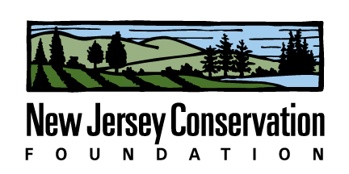

Winter 2015 Internship Description

Position Title: Land Conservation Conference Intern

Company Description:
New Jersey Conservation Foundation is a nonprofit organization that preserves open space and farmland throughout New Jersey. New Jersey Conservation Foundation engages in a conservation assistance program by providing educational opportunities for other conservation groups to share best practices, strategies and techniques. As part of this program of conservation assistance, we coordinate a statewide educational conference every year about preserving New Jersey’s open space and farmland. The next conference will take place on March 6, 2015. To learn more about the conference, visit www.njconservation.org/rally.

Job Description: A communications class from Rutgers University developed a marketing plan for this annual event. The intern will implement some of the recommendations from this report, particularly as it relates to marketing and use of social media techniques. The intern will be engaged in all aspects of the conference organization. Interest in marketing, communications, social engagement and event planning would also be of use. Position could be full-time or part-time.

Number of openings: 1

Desired Majors: Marketing, communications. Other majors will also be considered. An interest in the environment and land conservation is desired.

Company Name: New Jersey Conservation Foundation
Company Address: 170 Longview Road, Far Hills, NJ 07931
Company Website: njconservation.org
Contact Name and Title: Laura Szwak, Director, Education & Outreach
Contact Email: Laura@njconservation.org
Contact Phone Number: 908-234-1225 ext. 117

Stipend: $1000 for 200 hours of work (10 weeks at 20 hours/week) provided.

Start Date: Position is available starting January 5, 2015. Intern must be able to work through March 13, 2015.

Location of Internship: New Jersey Conservation Foundation headquarters, 170 Longview Road, Far Hills. The intern is expected to come to the office at least once a week. Some work may be done offsite.

