Reality TV Exec Says the Genre 'is not going away'
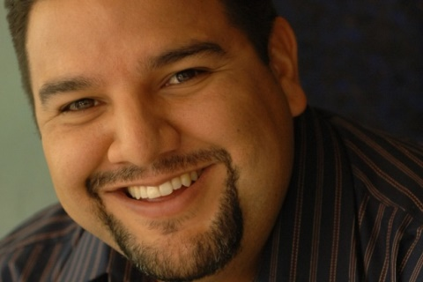
Unfortunately, this town operates a lot out of fear. The minute "Utopia" tanked, if you had the [guts] to walk in a room and pitch something similar to "Utopia," nobody is going to buy it. If you really looked at unscripted right now, a lot of shows are doing really well, especially in cable. Even in broadcast, "The Voice" still does well.
Los Angeles Times 1.7.16
http://www.latimes.com/entertainment/envelope/cotown/la-et-ct-on-the-record-cris-abrego-20160107-story.html

