Report Assesses Compliance Costs of Calif. Data Privacy Law
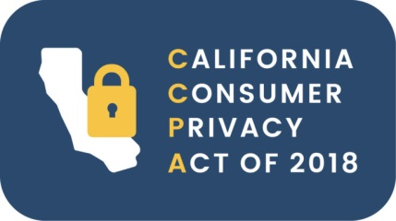
If the California Consumer Privacy Act is signed into law, initial compliance will cost businesses an estimated $55 billion, states an economic assessment prepared by an independent research firm for the state attorney general's office. "Some industries will be forced to completely revise their business models to incorporate the newly required data protections," the researchers wrote.
CNBC 10/5/19
https://www.cnbc.com/2019/10/05/california-consumer-privacy-act-ccpa-could-cost-companies-55-billion.html
Image credit:
https://termly.io/wp-content/uploads/2018/07/logo3-01-e1530862337888.jpg

