Rich NFL Deals Will Drive More Cord Cutting for MVPDs
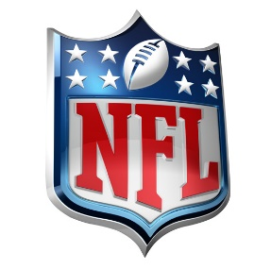
Deana Myers, research director at Kagan, broke down the new agreements with ABC, Amazon, ESPN, CBS, Fox, and NBC. She said that programming costs are sure to rise from this, in terms of both affiliate and retransmission fees. “These costs will, in turn, be funneled to [pay TV] customers and, as we have seen, costs can be a problem. Many consumers have cut the cord over pricing and that is likely to continue if the price of TV packages rise further,” Myers said during this week’s Stream TV Sports Summit.
Fierce Video 4.21.21
https://www.fiercevideo.com/video/rich-nfl-deals-will-drive-more-cord-cutting-for-mvpds-analyst?utm_source=Listrak&utm_medium=Email&utm_term=Analyst%3a+Rich+NFL+Deals+Will+Drive+More+Cord+Cutting+For+MVPDs&utm_campaign=How+Shifting+Senior+Ranks+Are+Ushering+In+Rise+In+Diversity+At+Major+News+Outlets

