Rio Olympics Sets Streaming Record
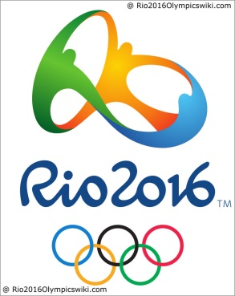
The 2016 Rio Olympics surpassed 2 billion minutes of streaming in its first 10 days and could surpass 3 billion views when the final week's tally is added. The viewership numbers already exceed the 1.46 billion combined streaming minutes reported for the 2012 London Olympics and 2014 Sochi Olympics.
Digital Trends 8/18/16
http://www.digitaltrends.com/movies/olympics-rio-live-stream-nbc/

