"Rogue One" Star Felicity Jones: "I want to be paid fairly"
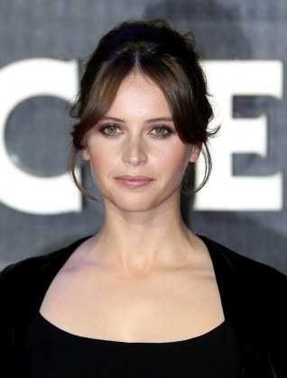
As the headliner of the much-anticipated "Rogue One: A Star Wars Story," Felicity Jones says she is keenly aware of the pay disparity in Hollywood and wants women to keep talking about it. "The opportunity to play someone determined, who's trying to find her skills as a leader; to be in a fantasy movie; to be able to do a leading female role in a film of that scale -- that's very, very rare," Jones said.
The Huffington Post 11/29/16
http://www.huffingtonpost.com/entry/felicity-jones-i-want-to-be-paid-fairly-for-the-work-that-im-doing_us_583d8d62e4b06539a78a57d0?section=us_women
Image source:
http://www4.pictures.stylebistro.com/gi/Felicity+Jones+Updos+Retro+Updo+fER54O78iHCx.jpg

