Roku Maintains Top Spot in Streaming Device Market
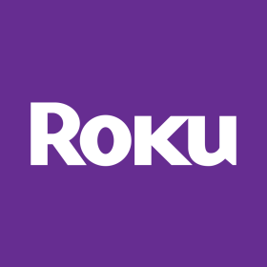
Roku remains the top provider of streaming devices, with 37% of the market share, Parks Associates has found. The company's products rated highly with consumers on usability, while Apple TV fared well in gaming and content purchases, and Google's market share slipped after a year of no updates.
MultichannelNews 5/31/18
https://www.multichannel.com/blog/roku-retains-edge-streaming-player-market

