Roku User Growth Re-Accelerates As Smart TV Supply Chain Pressures Ease
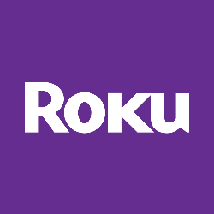
Roku announced the addition of 1.8 million active users in the second quarter, upping its U.S.-leading base of connected TV customers to 63.1 million. The figure represented re-accelerated growth for Roku, which only added 1.2 million active users in the first quarter and 1.5 million in the second quarter of 2021. Roku attributed that spry growth to improved smart TV shipments and pricing.
Next TV 7/28/22
https://www.nexttv.com/news/roku-user-growth-re-accelerates-as-smart-tv-supply-chain-pressures-ease?utm_source=SmartBrief&utm_medium=email&utm_campaign=C74FC4FA-5D4D-4151-8915-3043BA411DBE&utm_content=1862D140-AC23-491A-9CBB-5BE152015045&utm_term=a25693a1-51b6-4112-bde4-56bd420e983f

