Roku Hits 100M-Viewer Mark, Will Add More Services
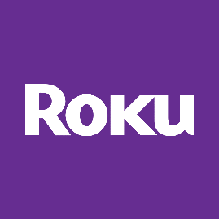
Roku earnings beat Wall Street expectations for the fourth quarter, and the company reported its channel reaching 100 million US residents for the first time. Future plans include smart TVs with the Roku brand, a lineup of free ad-supported streaming channels from Warner Bros. Discovery and onscreen ordering via a DoorDash deal.
Variety 2/15/23
https://variety.com/2023/digital/news/roku-q4-2023-earnings-roku-channel-100-million-1235523888/

