FCC's O'Rielly: Rolling Back Net Neutrality a Likely Priority
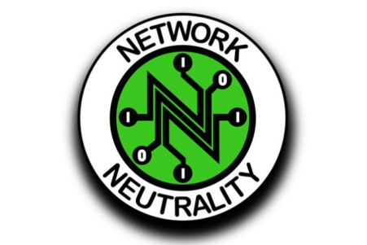
Federal Communications Commission Commissioner Michael O'Rielly has predicted that a Republican majority in the FCC may make rolling back net neutrality a priority but says that the decision is dependent upon the new chairperson. O'Rielly also called the Title II rules adopted in February "harmful" and said they "should never have been adopted in the first place."
Broadcasting & Cable 12/14/16
http://www.broadcastingcable.com/news/washington/fccs-orielly-shares-many-trump-policy-positions/161818

