Rolling Stone Liable on Multiple Claims in a Defamation Suit
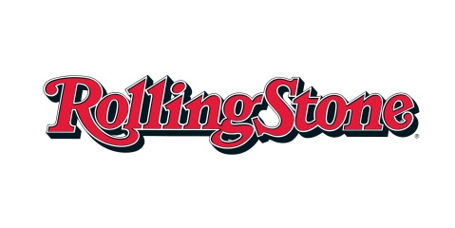
The 10-member jury found journalist Sabrina Erdely was responsible for libel, with actual malice. Jurors also said Rolling Stone and its publisher were responsible for defaming University of Virginia administrator Nicole Eramo. Eramo claimed she was unfairly portrayed in the article as trying to sweep “Jackie’s” sexual assault under the rug in order to protect the university.
CBS News 11.4.16
http://www.cbsnews.com/news/verdict-reached-in-rolling-stone-defamation-lawsuit/

