Rovi Buys TiVo for $1.1 Billion
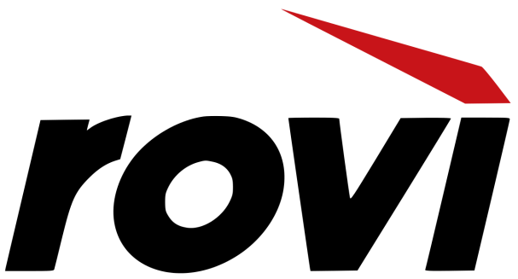
Entertainment technology company Rovi has purchased original DVR service TiVo for $1.1 billion, or $10.70 per share. Talks of such an acquisition heated up last month, and now it’s official — pending customary regulatory approval, of course.
The Wrap 4.29.16
http://www.thewrap.com/rovi-acquires-tivo-1-1-billion-dvr/

