Russia Seeks PR Agencies to Improve Image Abroad
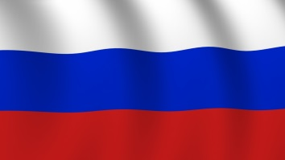
The Russian government is set to spend big to try and improve its image in the international arena and it is seeking assistance from Western PR agencies. According to Nikolay Nikiforov, Russia’s minister of communications, fees for the image-rebuilding plan will range from $30-50 million per year. Negotiations with agencies are ongoing, but no deals have been signed yet.
PR Week 11.1.16
http://www.prweek.com/article/1414140/russia-seeks-pr-agencies-improve-image-abroad?spMailingID=15839969&spUserID=Mjk2MjI5NDc2NjI0S0&spJobID=902395672&spReportId=OTAyMzk1NjcyS0

