Actors Strike Ends As SAG-AFTRA OKs Deal With Studios
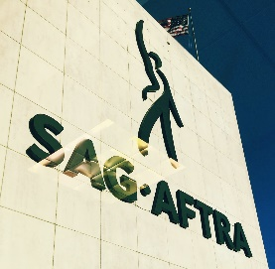
The negotiating committee for the Screen Actors Guild-American Federation of Television and Radio Artists has agreed on a new contract with the major studios. The union's board of directors will vote on the deal on Friday, and production will probably start as quickly as possible .
Variety 11.8.23
https://variety.com/2023/tv/news/sag-aftra-tentative-deal-historic-strike-1235771894/

