Same-Day HBO Max Film Releases Will Stop in 2022
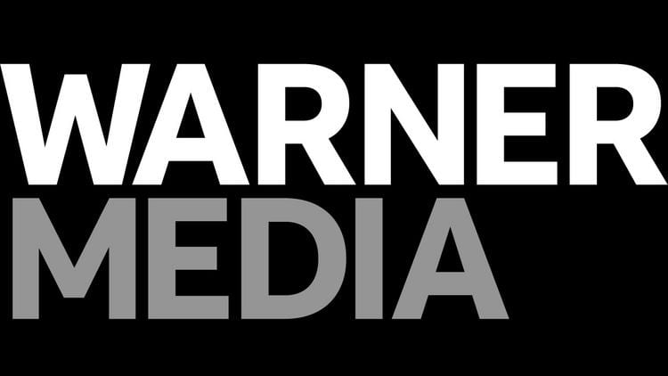
WarnerMedia and Regal Cinemas have agreed to a 45-day exclusive theatrical window for film releases starting in 2022. While the deal ends the 2021 practice of putting out movies simultaneously on HBO Max and in cinemas, it still halves the traditional exclusivity period.
Reuters 3/23/21
https://www.reuters.com/article/us-cineworld-reopening/cineworld-seeks-to-beat-pandemic-blues-with-warner-bros-deal-idUSKBN2BF0Q4

