Saudi Prince Debuts Video Game Featuring Female Warriors
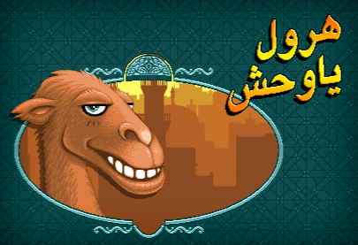
Prince Fahad bin Faisal Al Saud has released a video game through his NA3M design company featuring female warriors who drive and fight injustice in Saudi Arabia. As a close relation to the King, Prince Fahad's "Saudi Girls Revolution" could help call attention to the country's discriminatory social policies, Heather Dockray writes. "If we can tell people stories about women driving . . . maybe it will actually happen," Prince Fahad said.
Good.is 5/25/15
http://magazine.good.is/articles/video-game-allows-saudi-women-to-drive-cars

