Journalists Aim To Highlight Big Tech's Effect On Local News
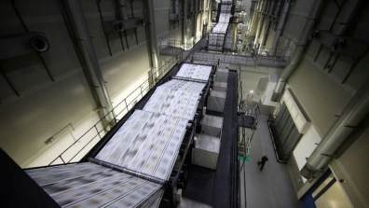
A group of journalists who have all recently lost their jobs are launching the "Save Journalism Project" -- a campaign aimed at educating lawmakers and the public on how companies like Facebook and Google are hurting the news industry. Lawmakers are currently considering legislation that would allow news organizations to bargain as a single unit with tech companies for increases in their online ad revenue.
The Hill 6/20/19
https://thehill.com/policy/technology/449565-laid-off-journalists-launch-first-ad-campaign-targeting-google-facebook
Image credit:
https://thehill.com/sites/default/files/styles/thumb_small_article/public/newspaper_1.jpg?itok=StxpfO3W

