Saving the Sounds of Radio
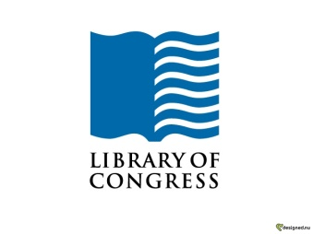
The Library of Congress has increased the scope and scale of preserved radio recordings in recent years, fighting challenges such as degradation of fragile media. Today, more than 30,000 recordings from National Public Radio, Armed Forces Radio and Television, and NBC Radio have been preserved in digital format for notable events, including Charles Lindbergh's trans-Atlantic flight.
Library Of Congress 7/28/16
http://blogs.loc.gov/loc/2016/07/lcm-saving-the-sounds-of-radio/

