Screen TV Shows in Theaters
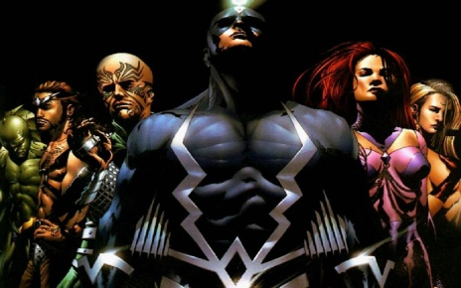
Imax Corp., the giant movie screen company, recently partnered with Marvel Television and ABC Television to make the upcoming superhero series “Inhumans,” set to hit the cinema weeks before it appears on TV. It’s the boldest move yet to blur the already fuzzy lines between films for the big screen and shows for the small screen.
Los Angeles Times 1.3.17
http://www.latimes.com/business/hollywood/la-fi-ct-imax-tv-20161219-story.html

