Scripted Shows Fall Further Out of TV's Top 50
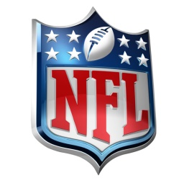
In a year marked by two audience-friendly quadrennial events and a once-in-a-lifetime World Series showdown, NFL games still accounted for more than half of the year's top 50 most-watched broadcasts, leaving little doubt that football's outsized influence over the culture remains formidable.
Advertising Age 1.4.17
http://adage.com/article/media/scripted-tv-falls-2016-top-50-chart/307348/?utm_source=daily_email&utm_medium=newsletter&utm_campaign=adage&ttl=1484094758?utm_visit=113450

