Scrutinizing the Effects of Digital Technology on Mental Health
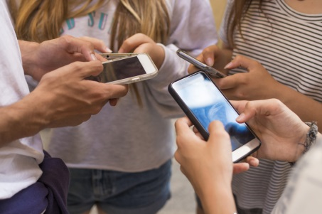
Scientists have identified correlations, and some causations, between an increase in the rates of depression, anxiety and self-harm in US and UK teenagers around the same time social media networks became more prevalent. What’s more, the platform’s youngest users, and girls especially, are the most vulnerable to its negative influences.
Nature 2.10.20
https://www.nature.com/articles/d41586-020-00296-x?utm_source=First+Draft+Subscribers&utm_campaign=51ff1a684f-EMAIL_CAMPAIGN_2019_09_06_03_37_COPY_01&utm_medium=email&utm_term=0_2f24949eb0-51ff1a684f-264114841&mc_cid=51ff1a684f&mc_eid=bca39b7a45
Image credit:
https://cdn.givingcompass.org/wp-content/uploads/2019/01/02105103/How-Using-Social-Media-Affects-Teenagers.jpg

