Senate Dems Ask ISPs to Lift Fees, Caps for Remote Learning
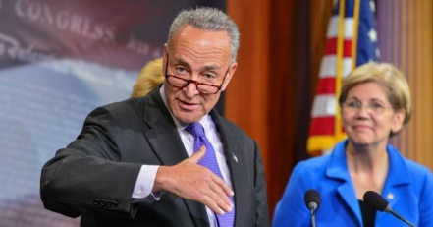
Some high-profile Senate Democrats urged internet service providers to help students returning to school by temporarily lifting overage fees and data caps as well as taking steps to expand their coverage. They sent a letter to CEOs of Comcast, Charter Communications, Cox Communications and other ISPs after the Federal Communications Commission's "Keep America Connected" Pledge expired over the summer.
The Verge 9.11.20
https://www.theverge.com/2020/9/11/21432866/elizabeth-warren-mark-warner-att-tmobile-verizon-overage-fees-students-pandemic
Image credit:
https://www.politicususa.com/wp-content/uploads/2016/12/schumer-warren-senate.jpg

