It's Moving Day on Sesame Street... to HBO
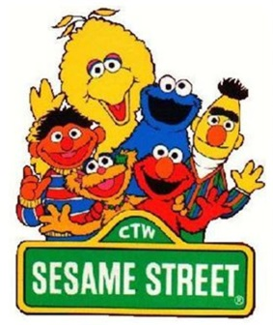
As part of a licensing deal forged by the premium cable TV network and the producers of "Sesame Street," HBO will carry first-run episodes of the venerable kids' program through 2020. The first episodes of "Sesame Street" funded by Time Warner's cable unit will begin airing on HBO later this fall.
Advertising Age 8.13.15
http://adage.com/article/media/moving-day-sesame-street/299961/?utm_source=mediaworks&utm_medium=newsletter&utm_campaign=adage&ttl=1440103531

