Short-Form Video Among 3 PR Trends For 2024
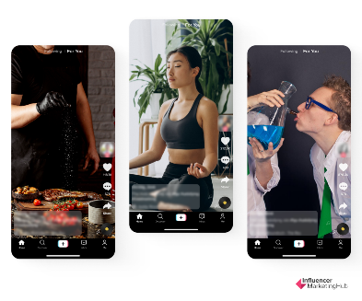
PR professionals can expect three prevailing trends as we move further into 2024, including the rise in measurement capabilities that pave a path for PR to be seen as an essential business function, writes Nicole Gainer, associate vice president at Red Thread PR. Businesses will also want to increase the use of short-form videos to suit shortening consumer attention spans and ensure their corporate social responsibility efforts align with their brand purpose and value.
PRSAY 2.2.24
https://prsay.prsa.org/2024/02/02/3-trends-for-comms-pros-to-watch-1-month-into-2024/
Image copyright:
https://influencermarketinghub.com/wp-content/uploads/2022/11/image-6-1.png

