Should There Be More Regulation Around Influencer Marketing?
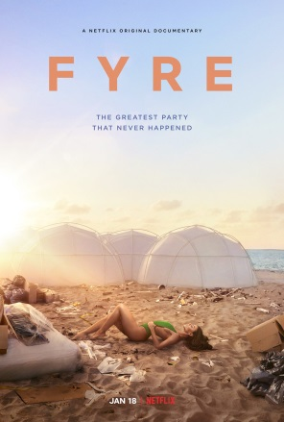
In the wake of the Netflix documentary "Fyre: The Greatest Party That Never Happened," which shed a light on the power of influencers with massive followings, Chris Stokel-Walker questions whether regulation would help put a stop to fake influencer marketing. The space is largely unregulated, with nothing stopping brands from approaching influencers to promote their products, although influencers are supposed to use a hashtag to inform the audience of its paid-sponsorship nature.
The Guardian (London) 2/3/19
https://www.theguardian.com/technology/2019/feb/03/instagram-beware-bad-influencers-product-twitter-snapchat-fyre-kendall-jenner-bella-hadid

