Sinclair, Yankees, Amazon Buy YES Network
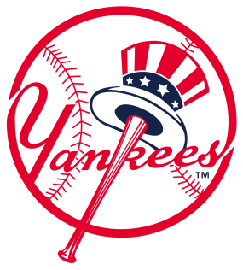
Sinclair Broadband Group, which already owns 21 regional sports networks, is adding to its portfolio by partnering with the New York Yankees, Amazon and private equity firms to buy the YES Network from Disney for $3.47 billion with the team holding the largest share at about 26%, once the deal is finalized. Sinclair will have a 20% stake with Amazon buying 15% with an option to eventually obtain more.
Deadline Hollywood 8/29/19
https://deadline.com/2019/08/new-york-yankees-executive-assessing-yes-deal-teases-baseball-streaming-shift-1202707729/

