Smart Speaker Shopping Gains Popularity
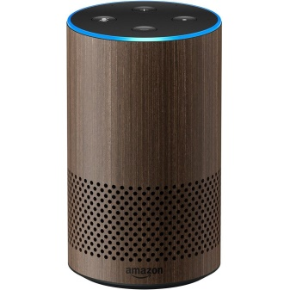
In 2019, 21 million people are expected to make a purchase via smart speaker and 31 million people are expected to tune into their devices to research, browse and add items to a shopping cart, a nearly 32% increase from 2018, according to eMarketer research. "New users are testing out the shopping-related features of their devices, and early adopters continue to utilize voice to search for products, ask for prices, and more," said eMarketer analyst Jaimie Chung, who also noted that an inability to see products remains a hindrance.
eMarketer 7/8/19
https://www.emarketer.com/content/smart-speaker-shopping-gains-traction
Image credit:
https://lookadevice.com/wp-content/uploads/2018/04/Walnut-Finish-Echo-Smart-speaker-with-Alexa.jpg

