55% Of Broadband Homes Have A Smart TV
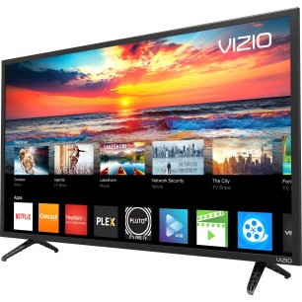
Smart TVs were present in 55% of US homes with broadband service during the third quarter of last year, about the same as in the first quarter, Parks Associates reports. The use of streaming media devices declined from earlier in the year to less than 40%, while the recent drop in gaming consoles leveled off.
MediaPost Communications (free registration) 3/18/22
https://www.mediapost.com/publications/article/372222/more-than-half-of-us-broadband-households-now-ow.html
Image credit:
https://i5.walmartimages.com/asr/2aa59abd-3809-4cf5-9ebf-66365c38cb2e.1b3c37d9a592da238fd30c2100356ad7.jpeg

