Smartphones the Dominant Device for Millennials, Older Generations
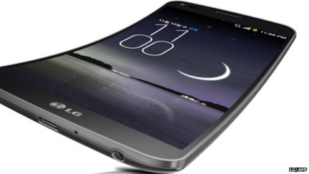
Smartphones are the main device for more than 9 in 10 millennials and large majorities of older generations, according to an international survey by Adobe. It also found that nearly two-thirds of US mobile users are willing to share their e-mail addresses in exchange for ad-supported premium content.
Multichannel News 10/6/15
http://www.multichannel.com/blog/bauminator/study-92-millennials-say-smartphone-primary-device/394335

